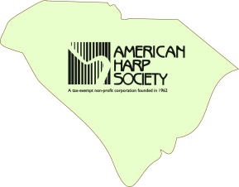
Upstate South Carolina Chapter
of the American Harp Society
MEMBERSHIP APPLICATION

Name ______________________________________________________________________________
Mailing Address _____________________________________________________________________
_____________________________________________________________________

E-Mail Address ________________________________________________________________________
Primary Phone ____________________________________
Interest in harp (check all that apply):

- Adult Student
- Composer
- Friend of Harp
- Professional
- Student
- Teacher
Are you currently a member of the American Harp Society?

- Yes
- No
SC Chapter yearly dues: $25.00
Membership is Yearly on your anniversary date.
Signature: _____________________________ Date: ________________

Please send check payable to SC Chapter AHS along with the form to the following address:
SC Chapter AHS
222 Club Drive
Simpsonville, SC 29681

